Given an m x n picture consisting of black 'B' and white 'W' pixels and an integer target, return *the number of****black****lonely pixels*.

A black lonely pixel is a character 'B' that located at a specific position (r, c) where:

* Row r and column c both contain exactly target black pixels.
* For all rows that have a black pixel at column c, they should be exactly the same as row r.

**Example 1:**

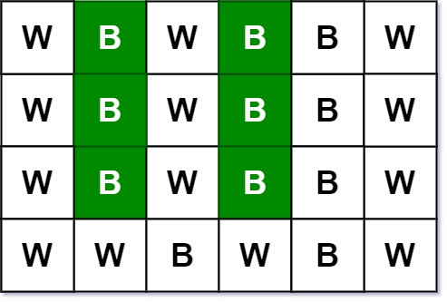

**Input:** picture = [["W","B","W","B","B","W"],["W","B","W","B","B","W"],["W","B","W","B","B","W"],["W","W","B","W","B","W"]], target = 3

**Output:** 6

**Explanation:** All the green 'B' are the black pixels we need (all 'B's at column 1 and 3).

Take 'B' at row r = 0 and column c = 1 as an example:

- Rule 1, row r = 0 and column c = 1 both have exactly target = 3 black pixels.

- Rule 2, the rows have black pixel at column c = 1 are row 0, row 1 and row 2. They are exactly the same as row r = 0.

**Example 2:**

**Input:** picture = [["W","W","B"],["W","W","B"],["W","W","B"]], target = 1

**Output:** 0

**Constraints:**

* m == picture.length
* n == picture[i].length
* 1 <= m, n <= 200
* picture[i][j] is 'W' or 'B'.
* 1 <= target <= min(m, n)